Maths  Mon-Fri  Should be done in order | Daily counting from any number forwards and backwards. Counting in 2’s, 5’s and 10’s Practise writing numbers 1-20 in words.
 | Monday  Find a half  https://wrm-13b48.kxcdn.com/wp-content/uploads/2020/homelearning/year-1/Lesson-5-Y1-Summer-Block-2-WO2-Find-a-half-2-2020.pdf | Tuesday  Find a quarter  https://wrm-13b48.kxcdn.com/wp-content/uploads/2020/homelearning/year-1/Lesson-2-Y1-Summer-Block-2-WO3-Find-a-quarter-1-2020.pdf | Wednesday  Find a quarter (2)  https://wrm-13b48.kxcdn.com/wp-content/uploads/2020/homelearning/year-1/Lesson-3-Y1-Summer-Block-2-WO4-Find-a-quarter-2-2020.pdf | Thursday  Problem Solving  https://wrm-13b48.kxcdn.com/wp-content/uploads/2020/homelearning/year-1/Lesson-4-Problem-Solving.pdf | Friday  Maths Challenges  https://wrm-13b48.kxcdn.com/wp-content/uploads/2020/04/Family-Challenge-Friday-24th.pdf
English  Mon-Fri  Choose one-a-day. | Daily Reading, Phonics ( Practise Phase 3 and Phase 5 sounds) and spelling practice ( Spellings- Common exception words and the days of the week ) Phonics game 2DO task on Purple Mash
 | Read the story Jack and the Beanstalk.  https://www.bbc.co.uk/teach/class-clips-video/english-ks1-jack-and-the-beanstalk-home/zff42sg  Activity: Children to draw a story map retelling the story of Jack and the Beanstalk.  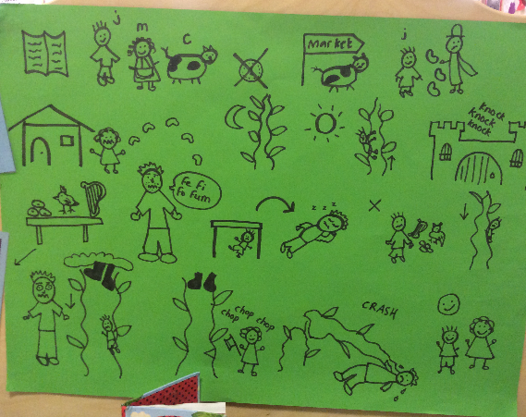 | Grammar, Punctuation and Spelling  Question or not a question  Please complete the punctuation worksheets.  file:///E:/Clownfish%202019-2020/GPS%20Classroom%20%20Secrets/Term%205/Week%202/GPS-Year-1-Summer-Block-1-Step-4-AR-Question-or-not-a-Question.pdf | Comprehension  Jack and the Beanstalk  Please read through the text and answer the questions.  https://content.twinkl.co.uk/resource/1c/7f/t-l-51714-jack-and-the-beanstalk-traditional-tales-differentiated-reading-comprehension-activity.pdf?__token__=exp=1587465472~acl=%2Fresource%2F1c%2F7f%2Ft-l-51714-jack-and-the-beanstalk-traditional-tales-differentiated-reading-comprehension-activity.pdf%2A~hmac=20d250040a0a0019603e6d770978458d2a144515ca3a7814456b17d4dc21d96a | Thursday and Friday  Rye Writers  Rye-Writers is best done on consecutive days. You can also choose when to do the 2 sessions could be on the same day, just do 2 curriculum subjects on the other day.  To write a woodland adventure story. You could imagine that you would follow the pathway and meet an animal or magical creature. What would you do together? Where would you go?  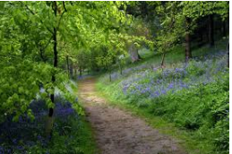
Curriculum  Choose one-a-day. | Science  Recap on the parts of the tree and talk about each part’s function e.g The branches help to transport  water to the leaves.  Activity To label the parts of a tree and write about each part’s function. | Geography  To draw a map of an imaginary woodland where Jack might live. Please create a simple key for your map, e.g. trees symbol for woodland. | ICT  Purple Mash 2Do Task – Coding  Air traffic control. Programme the planes to take off.  PSHE- My body  Can you draw and label yourself?  Purple Mash 2Do Task | Art  Look at Van Gogh’s Sunflowers painting and draw or paint your own version.  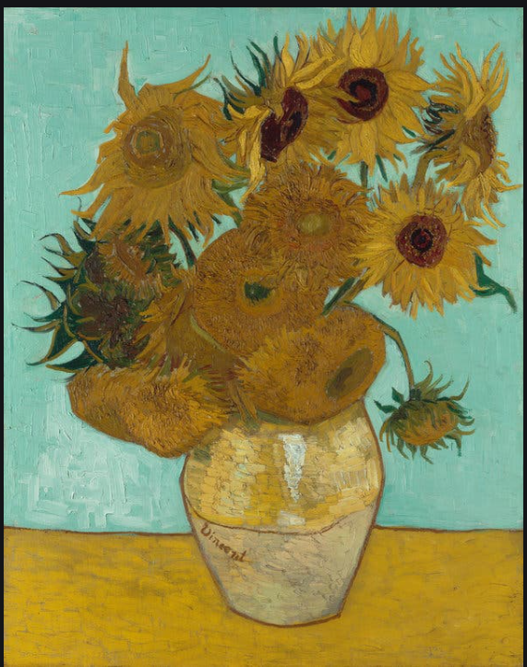 | STEM  Collect sticks, pine cones etc. and build a bug hotel.  