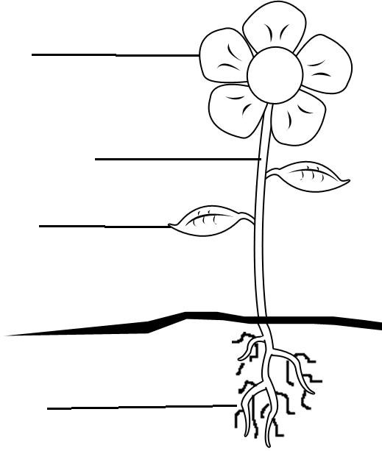

ROOTS STEM LEAVES FLOWER
The of a plant produce seeds which form new plants.
The make the food for the plant. They take the water and mineral salts and use them together with sunlight and carbon-dioxide to make food. This is called Photosynthesis.
The is like a straw. It moves water around the plant. It raises the leaves and flowers of the plant off the ground.
The take in water and minerals from the soil. They anchor the plant into the ground.

ROOTS STEM LEAVES FLOWER
The makes seed to make a new flower grow.
The sit in the sunshine, and make food for the plant.
The is like a straw. It moves water around the plant. It is long and the flower and leaves hang from it.
The take in water and food from the soil. They also help the flower to stand up still.

