Wednesday21st October 2020 Book Talk- Enable
Lenses we have focused on:
- Fantastics: Imagining
- Stylistics: Text Layout/Structure
- Analytics: Your personal opinions

Pirate Poetry
Imagining | Imagine you were Blackbeard or Anne Bonney. What would you look like?

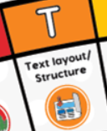  Text Layout/ Structure | Which words in the poem about Blackbeard rhyme?

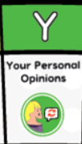  Your Personal Opinions | What do you like about the poem?

