Other – Choose a castle to research. Create an information poster about it. When was it built? Who lived there? Has it had any famous visitors? | Other – Read a book about a castle. This could be fiction or non-fiction. Write a book review to share your thoughts. Book review template attached on webpage. | Other – Find out about King Arthur or St George. Who were they and why are their stories still told?
Other – Explore walls made of different materials. Take some photos. What do they look like? What do they feel like? Why has that material been used to make the wall? | Other – Build your own castle. This could be a model using a box, paper or building blocks or why not even a sandcastle! What details will you add on the inside? | Other - Who lived and worked in a castle? Find out what everyday life was like.
Other – King or Queen for the day. What would you do? Would you prefer to live in a castle or a palace? Would you have knights to fight dragons? Would you have a jester or musician for entertainment? Would you hold a ball for all of your friends? | Other – Design your own coat of arms. These often used to include animals. Why were these used on shields? Explain why you have chosen each image on your coat of arms.  Shield template attached on webpage.  How else did Knights keep themselves safe? | Other – Knight’s Shield Pizzas and Dragon Biscuits. Get creative in the kitchen. You might even want to plan your own healthy banquet to eat for dinner.  Recipes attached on webpage,
Maths – Make some Dragon Eggs. Put water and different colour food dye inside balloons. By filling the balloons up with different amounts of water you can make different size eggs! Freeze and then peel off the balloon. Weigh your dragon eggs and order them from heaviest to lightest. | Maths – A Castle or a Cave. Design and make a castle or a cave for a chosen animal – e.g. dragon, king or bat. It must be no bigger than 50cm by 50cm. Think about what it needs to be e.g. warm for a dragon, strong for a king, dark for a bat. | Maths – Make a 2D shape castle. What shapes will you use for each part of the castle? Why?  What do you know about each shape’s properties?
Maths – Create a castle wall.  You might like to use different sized or shape sponges. What patterns can you create? | Maths – Build your own moat. What can you find to use? Bottles, tubes, pipes, guttering? How much water can it hold? How fast can you make it move round?  If you don’t fancy getting wet why not try building a bridge. How long will it be? What will you use to make it? How strong will it be? Can it hold 100g? What’s the maximum amount of weight it can hold? | Maths – Measure the Knights. Can you remember how to measure accurately? Can you order the knights from shortest to tallest? Can you draw your own knights and measure them? You could even draw some really big knights on the wall or floor outside using chalk. What will you use to measure them?  Sheet attached on webpage.
Maths – Counting in 2’s, 5’s and 10’s. Do you know how to count in 2’s, 5’s and 10’s? Make towers going up in these amounts. You could use wooden blocks, Lego or cubes. If you can count in 2’s, 5’s and 10’s try counting in 3’s, 4’s and 6’s! | Maths – Put your model castle outside in the Sun.  Draw round it’s shadow at 9am, 12pm, 3pm and 6pm. What do you notice? Why do you think this has happened? Do you know what position your castle is in at the different times of day? | Maths – Make your own crown. Measure round your head and cut a strip of paper to fit. Now try drawing round some 2D shapes and cutting them out to decorate it!
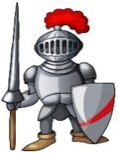
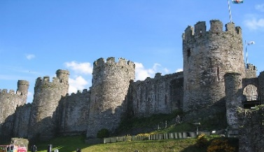
Please choose one Maths challenge and one Other challenge to complete each week and put the date in the box when you have done it. Remember you should also be practising your spellings every week and reading daily – you can read your school book or a book on Reading Eggs. We have left these tasks fairly open ended so that you can be creative! Make things look nice through adding colour. Use your imagination and take pride in your work. You can take photos, use a computer or record through writing and drawing. We don’t expect you to do all of these tasks but if you want to that is fine. Please bring your homework book in by Thursday each week and date the work you have completed. Happy learning and have fun!

