12.01.2021 Level 1
LI: To find the difference between two numbers
Steps to success:
- I can find the difference by solving problems using numbers up to 10. (Level 1)
- I can find the difference by solving problems using 1 and 2 digit numbers. (Level 2)
- I can find the difference by solving problems using the most efficient method to help me. (Level 3)
Reasoning and problem solving: can you explain your answers?

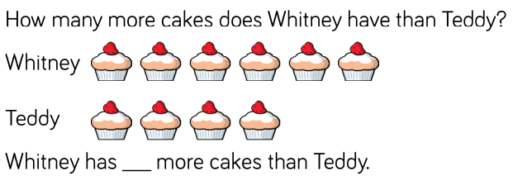

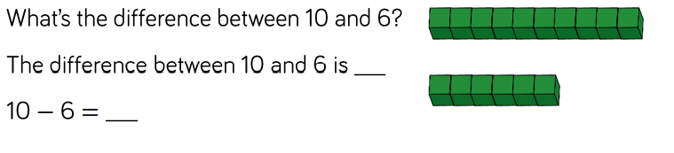

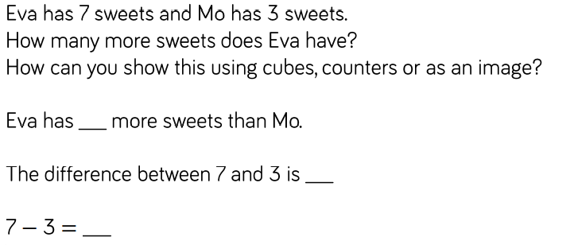

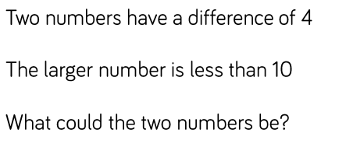

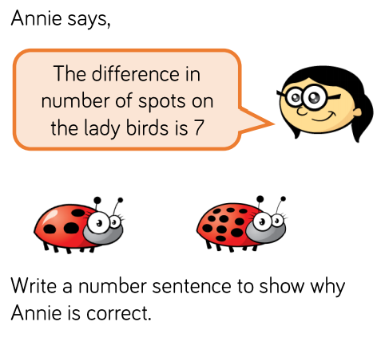

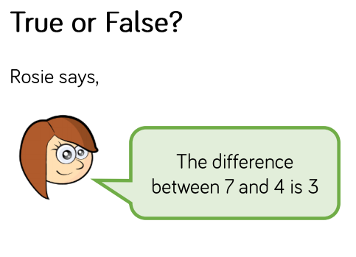

How do you know?

