11.01.2021 Level 3
LI: To subtract 2 numbers.
Steps to success:
- I can solve number problems by subtracting numbers up to 10. (Level 1)
- I can solve number problems by subtracting 1 and 2 digit numbers. (Level 2)
- I solve number problems with subtraction by writing the sums in different ways. (Level 3)
Reasoning and problem solving: can you explain your answers?

Always subtract the ones column first. Be careful today you need to carry.

Here is an example to help you.
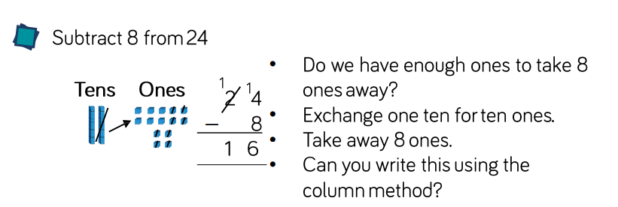

l) |  | Tens | Ones |  | 2) |  | Tens | Ones |  | 3) |  | Tens | Ones |  | 4) |  | Tens | Ones
 |  | 2 | 4 |  |  |  | 3 | 2 |  |  |  | 4 | 5 |  |  |  | 5 | 3
 | - |  | 5 |  |  | - |  | 8 |  |  | - |  | 3 |  |  | - |  | 6
5) |  | Tens | Ones |  | 6) |  | Tens | Ones |  | 7) |  | Tens | Ones |  | 8) |  | Tens | Ones
 |  | 6 | 1 |  |  |  | 7 | 4 |  |  |  | 8 | 0 |  |  |  | 9 | 1
 | - |  | 7 |  |  | - |  | 8 |  |  | - |  | 9 |  |  | - |  | 5

9) |  | Tens | Ones |  | 10) |  | Tens | Ones |  | 11) |  | Tens | Ones |  | 12) |  | Tens | Ones
 |  | 2 | 1 |  |  |  | 3 | 4 |  |  |  | 4 | 5 |  |  |  | 5 | 3
 | - | 1 | 8 |  |  | - | 2 | 6 |  |  | - | 1 | 7 |  |  | - | 3 | 9
13) |  | Tens | Ones |  | 14) |  | Tens | Ones |  | 15) |  | Tens | Ones |  | 16) |  | Tens | Ones
 |  | 6 | 2 |  |  |  | 7 | 3 |  |  |  | 8 | 5 |  |  |  | 9 | 6
 | - | 4 | 5 |  |  | - | 3 | 4 |  |  | - | 5 | 9 |  |  | - | 6 | 8
