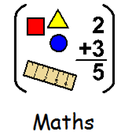
21.03.2022 Band 2
LI: To order length
Steps to Success:
- I measure length in centimetres and metres.
- I read to the nearest unit on a ruler.

Use the correct mathematical symbol to compare and order lengths.
I P T TA
Use the posters to complete the questions and problems.
You will need these images for two of the questions.

1.
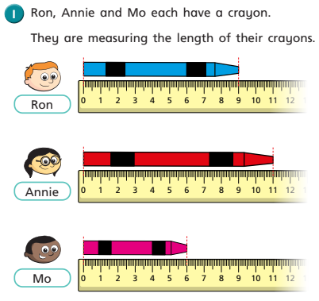

2.
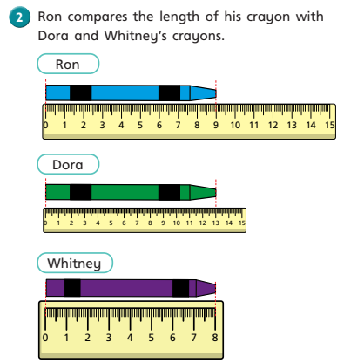
b.
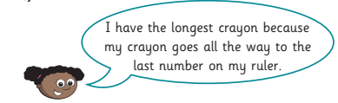

3.  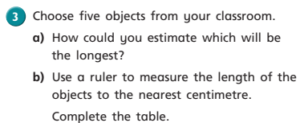 | 4.  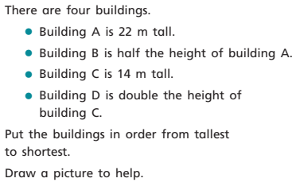

Band 2 Extension  5.  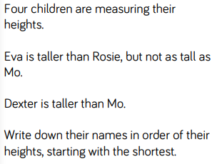 | Band 2 Extension  5.
6.  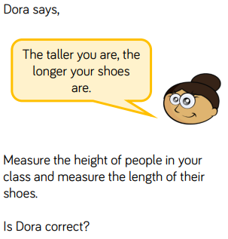 | 6.

