Dear Parents /Carers
As a celebration of the work that the children have done this term on ‘The Lion, The Witch and The Wardrobe’, we would like to have a dress up day next week – Wednesday 18th October. It would be great to see the children dress up as a character from the book / film.
We have included some pictures below to support your ideas.
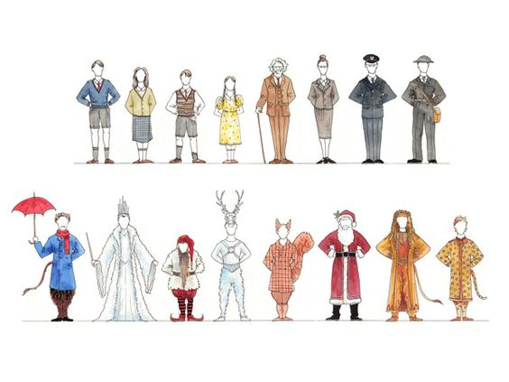
Thank you for your support
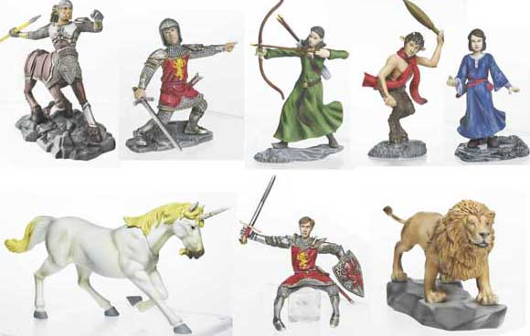
Mrs Wilson and Miss Mepham.

Dear Parents /Carers
As a celebration of the work that the children have done this term on ‘The Lion, The Witch and The Wardrobe’, we would like to have a dress up day next week – Wednesday 18th October. It would be great to see the children dress up as a character from the book / film.
We have included some pictures below to support your ideas.
Thank you for your support
Mrs Wilson and Miss Mepham.

