6th October 2017

Dear Parents,

We are pleased to announce that we will be running another holiday club during the October Half Term Holiday. The club will run for three days, Monday 23rd October, Tuesday 24th October and Wednesday 25th October.
Premier Sport Courses give children the opportunity to play sports in a safe environment under the supervision of qualified and experienced Premier Sport coaches. All their staff are fully insured and DBS checked with Child Protection and Emergency First Aid certification to give you the peace of mind you demand when placing your children into their care. All Premier Sport activities are packed with fun sport, fun break-times and fun games. Children will get to choose from a range of activities during the week. These include football, basketball, gymnastics, dance, fencing, archery, dodge ball and athletics.

The cost for the three days will be £21.00, and children will need to attend all 3 days. The course will start at 9.30 am and will finish at 3.30pm daily.

We only have 38 spaces available. We require full payment to secure your place, so please make sure you return the reply slip below with your payment as soon as possible to avoid disappointment and reserve your space. Payments can be made online via Schools Cash Office, Cash or Cheque

Entitlement to Pupil Premium
If your child is eligible for free school meals and you have previously received pupil premium funding for clubs, may we advise that we are reviewing how the funding is allocated for each child. We therefore ask that you indicate on the slip below that you would like to apply for the funding to be used for this club. We will then inform you of the outcome.

Your space will be confirmed via an email from the school a day or two after your payment has been received.

Yours sincerely
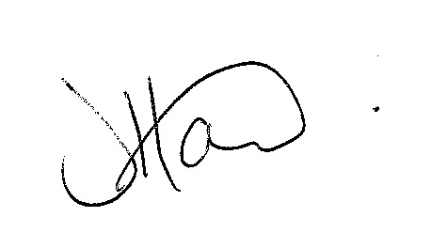
Ms J Howard
Headteacher
**********************************************************************************************************************

Child’s Name ………………………………………………………. Class ………………………………………

I have paid via Schools Cash Office
I enclose cash/cheque for £21.00
My child is entitled to FSM and I would like to apply for funding
(I enclose £10 payment to hold my child’s place)

In case of emergency please call: ……………………………….. on: …………………………………

Email address………………………………………………………

My child has the following medical condition ……………………………………………………………..
(please ensure they have inhalers with them if required).

Signed ……………………………………. Print Name………………………………..

