TUESDAY 17th OCTOBER 3:15pm
Rye Children’s Centre
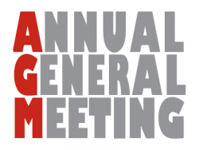
Our Annual General Meeting will take place in the Children’s Centre on Tuesday 17th October 2017 at 3:15pm (just before parents’ evening).

We would like to invite all parents and carers of children at Rye Community Primary School and Pugwash Nursery to join us on this occasion.

We will:
- present a summary of the 2016-17 activities and projects
- share our constitution, code of ethics and financial report
- share our plans and ideas for this year and the future
- and vote for PTA officers to be elected / re-elected
Hopefully, this will also be the occasion for the PTA to present or recruit new class reps for each class and to recruit new friends of the PTA who are willing to help for special events and projects.

There will be yummy cakes!

