7.1.21
Maths Meeting
L.I: I can answer division questions by using objects, pictures and other equipment. (band 1)

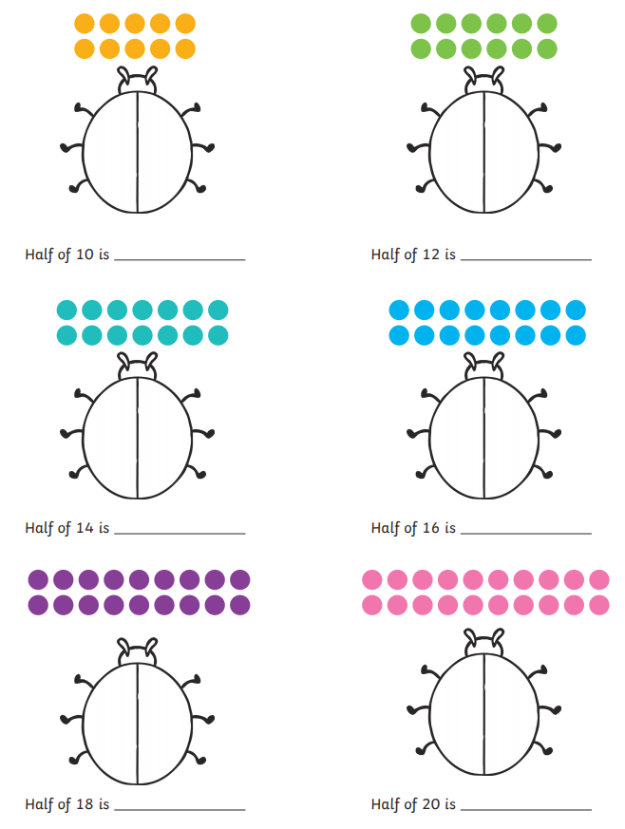

7.1.21
Maths Meeting
L.I: I can answer questions involving division mentally and with objects.(band 2)

