14.01.2021 Level 2
LI: To compare number sentences.
Steps to success:
- I can compare numbers using the > < and = signs using numbers up to 10. (Level 1)
- I can compare numbers using the > < and = signs using numbers up to 20. (Level 2)
- I can compare numbers using the > < and = signs using numbers up to 100. (Level 3)
Reasoning and problem solving: can you explain your answers?

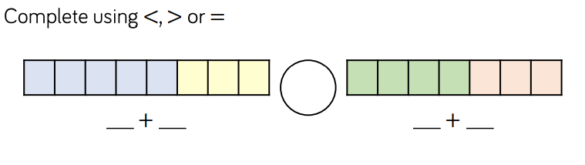
1

2

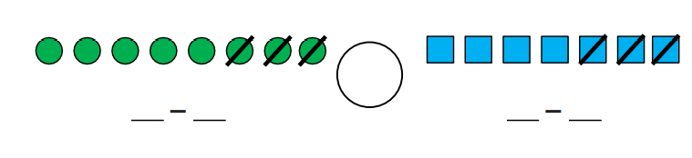

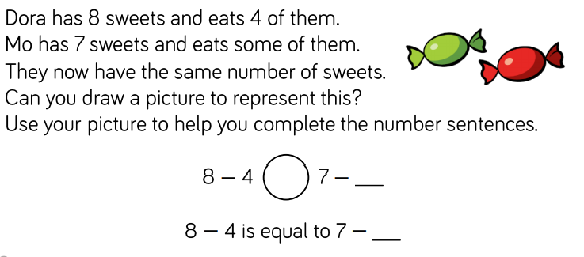
3

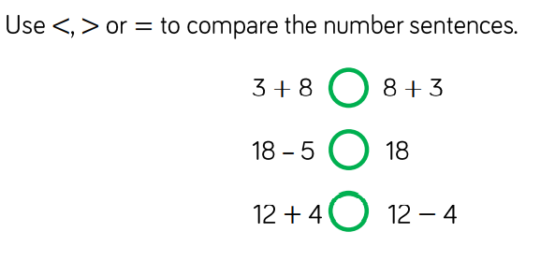
4

5

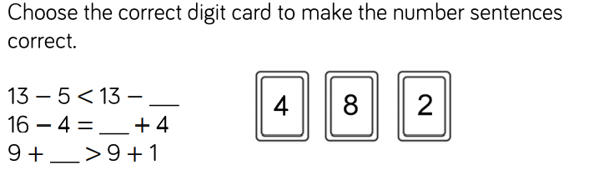

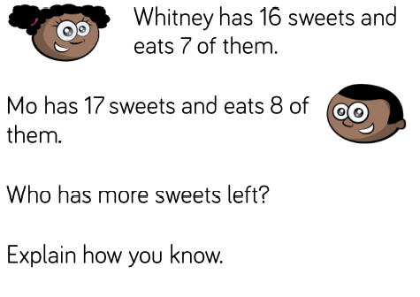
6

