15.01.2021 Level 3
LI: To solve + and – problems.
Steps to success:
- I can use what I know about + and – to help me solve a problem.
- I can explain my working out.
Reasoning and problem solving: can you explain your answers?
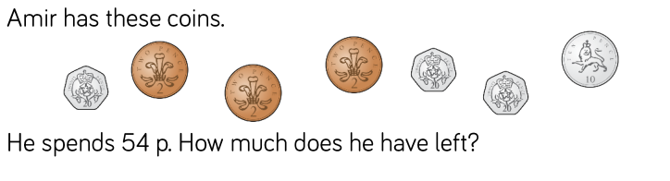
1

Show your working out

2

Show your working out

3

Annie finds a 20p coin.
She puts it with her other three 20p coins.
Does Annie have enough to ride the ghost train?

Explain why.

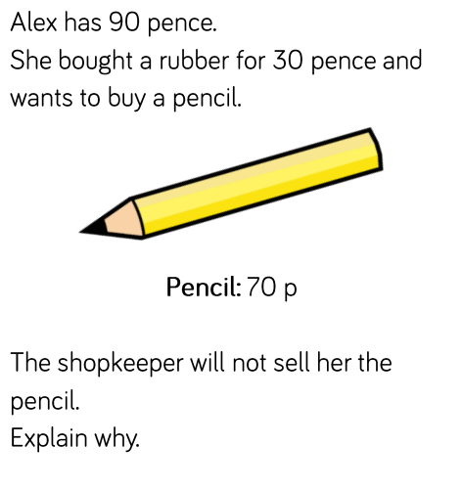
4

