08.09.10 Year 2
LI: To count up to 100
Steps to Success:
- I can count up to 100 objects.
- I write numbers to 100 in digits.
To count beyond 100.

1. Count and write the number of cars in the car park.
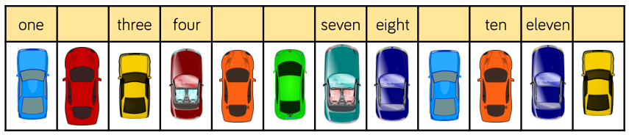
There are __________ cars in the car park.

2. What numbers are represented?
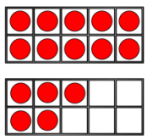
number
words

Match the numeral to the words:
