08.09.10 Year 1
LI: To count up to 20
Steps to Success:
- I can count up to 20 objects.
- I write numbers to 20 in digits.
To count beyond 20.
1. Fruit salad.
Count the different fruits very carefully.
Write how many of each you can see?
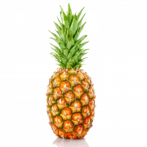

 | __________ apples |  | __________ bananas
 | __________ pineapples |  | __________ strawberries

2. Tens frames
Match the correct number to tens frame.
Can you draw the same number another way? You could use numicon, a picture or write the words.
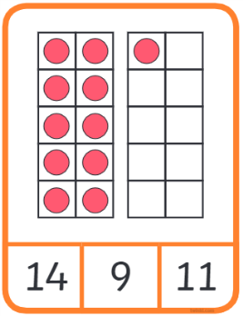
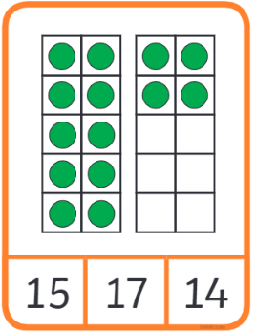
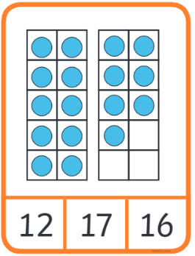
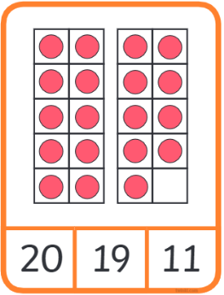
3. Show these numbers on to a tens frame.
5 | 8 | 12 | 20

